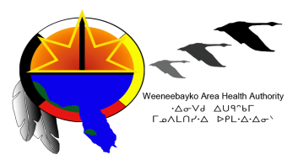  WeeneebayKO Area Health Authority (WAHA) | 19 Hospital Drive  Box 664  Moose Factory, ON POL 1W0  Tel: (705) 658-4544  Fax: (705) 658-4917
News Release
Contact: Crystal Culp, Director of Professional Practice, phone: (705) 658-4544 ext. 2228 | FOR IMMEDIATE RELEASE  Monday, December 7, 2015
Fibre Internet and Phone Repair Update – Attawapiskat Hospital

WAHA today announced that the Attawapiskat Hospital is experiencing issues with its internet and phone service, due to equipment damage. As a result of this, the Hospital will not have access to internet and its regular phone line (705) 997-2150 for part of tomorrow (Tuesday, December 8, 2015).

WAHA expects the internet and phone service to be working by noon tomorrow but encourages the public to visit www.waha.ca for updates as they become available. Members of the public can contact the Hospital via satellite phone at 1-613-855-0502 for service if required.

-30-

