 |  | 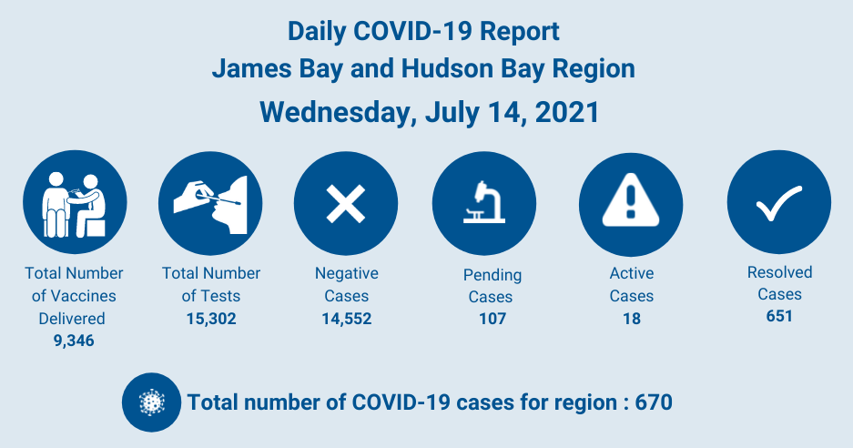
CHANGES IN EFFECT
- New! Provincial Re-opening Plan
  - Porcupine Public Health Unit (PPHU), with the rest of the province, is currently in phase two of the provincial reopening plan.
  - Click here for details of the public health measures and advice.
  - Note: Where the local community bylaws and the provincial restrictions differ, follow your local community bylaws.

Mandatory Pre-Screening for Patients and Escorts Travelling For Any Medical Appointments
- https://www.waha.ca/2021/06/08/mandatory-pre-screening-for-patients-and-escorts-travelling-for-any-medical-appointments/
- Speciality Clinic schedule for July
- Visit WAHA website for more details
 |  | HEALTH AND WELLNESS
There are currently 18 active cases in the region
- https://www.waha.ca/daily-covid-19-report/
For information about understanding COVID-19 Vaccines, visit:
- https://www.waha.ca/covid-19/vaccine/
For information about COVID-19 testing, visit:
  - www.waha.ca/covid-19/testing
It’s important to look after your mental wellness.
  - Check out a list of the supports available online:
WASH YOUR HANDS | USE COUGH ETIQUETTE |  | PRACTICE PHYSICAL DISTANCING |  | WEAR A MASK

